"Ice Melt"
Student Handout

Introduction
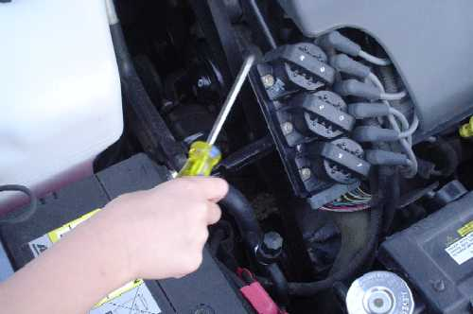
Most metals are excellent conductors of electricity. A common metal like copper is used to make the wires for electric cords and speakers. Other common materials like wood and plastic are great insulators. The handle of screwdriver can be made of wood or plastic, which may help reduce the chance of an electric shock if the metal end of the screwdriver touches a charged wire.
In today's lab, you will test whether the heat conductibility of three separate materials is similar to their electrical conductibility. The materials tested are very common and used to make a variety of household items that we use every day. The three materials that will be tested are metal, plastic and wood.

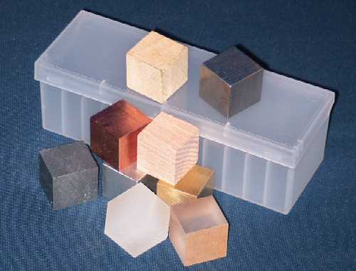
Materials
1 Piece of metal
1 Piece of wood
1 Piece of plastic
3 Cubes of ice (may need more retesting)
1 Stopwatch or clock with second hand
3 Styrofoam plates (runoff of water)
1 Ruler (metric)

Data Table #1

Sample  (material) | Length (cm) | Width (cm) | Height (cm) | Volume (cm³) | Mass  (g) | Density  (g/cm³)
1.

2.

3.
Process
Data Table #1
1. Describe each of the three samples (column #1).
2. Measure and enter the length, width and height of each sample (cm).
3. Calculate the volume of each sample (L x W x H).

4. Measure the mass of each sample (g).
5. Calculate the density of each sample (mass/volume).

6. Place each of the samples on a Styrofoam plate (use an insulated glove or tongs to transfer the samples).
7. Place a cube of ice on each of the samples – you may need to steady the ice (used an insulated glove or tongs to transfer the ice).
8. Make an initial observation and record on table #2; make eight additional observations (see time schedule below).

Data Table #2
Observation | Sample #1 | Sample #2 | Sample #3
Initial
1 (min)
3 (min)
5 (min)
7 (min)
9 (min)
11 (min)
13 (min)
15 (min)
9. Remove the ice from each of the samples. Note any observations below. (Also - note any temperature change in each of the samples.) ______________________________________________________________________________________________________________________________________________________________________________________________________________________________________________________________________________________________________________________________________________________________________________________________________________________________________________

10. Clean your testing area in accordance to your teacher's discretion.

Data analysis (Questions)

1. Why should a gloved hand or tongs be used to transfer the ice and samples during the initial setup? _______________________________________
_____________________________________________________________________________________________________________________________________________________________________________________________________________________________________________________________________________________________

2. Which sample had the greatest density? ________________________
_________________________________________________________
3.
a. Rank the following items from greatest to least on the ability to melt ice, cube of plastic, cube of metal, cube of wood ____________________
_________________________________________________________

b. Can you provide an explanation for your observations? _______________
___________________________________________________________________________________________________________________________________________________________________________

4. Did you notice a change in the rate at which the ice melted as additional observations were made? (why) _________________________________
___________________________________________________________________________________________________________________________________________________________________________
5. Most metals are excellent conductors of electricity. Other common materials like wood and plastic are great insulators. From your observations, do you feel the heat conductibility of the three separate materials are similar to their electrical conductibility? (Explain) ___________________
____________________________________________________________________________________________________________________________________________________________________________________________________________________________________
In the house - extension question
1. When a person removes a turkey from the oven, why can the metal aluminum foil covering the turkey be touched but the metal roaster pan can not be touched because it is to hot? ______________________________
____________________________________________________________________________________________________________________________________________________________________________________________________________________________________

